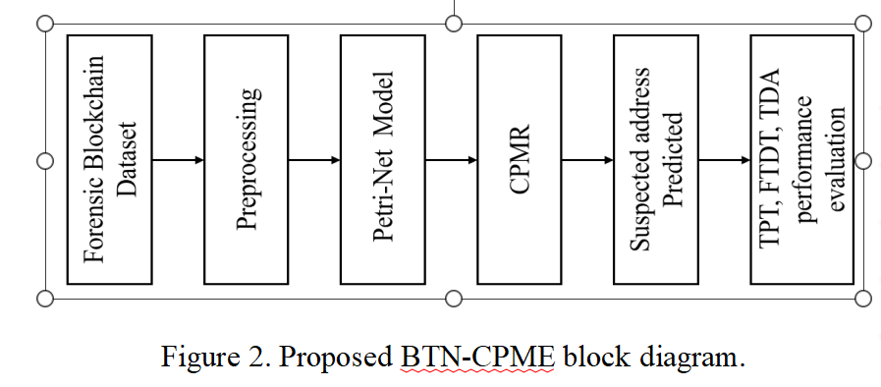
USE CASE DIAGRAM
An efficient use case diagram may assist your team in discussing and representing the following: Interactions that your programme or application has with other individuals, organisations, or computer systems in the outside world. objectives that your platform or application assists those entities (also known as actors) in accomplishing.
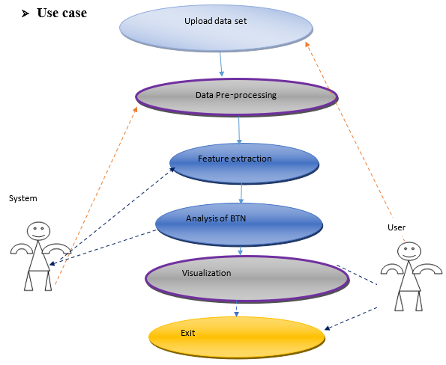

SEQUENCE DIAGRAM
Because it illustrates how and in what order a collection of items interact with one another, a sequence diagram is a sort of interaction diagram. Software engineers and other professionals working in the business world make use of these diagrams in order to better grasp the requirements for a new system or to describe an existing process. In certain circles, sequence diagrams are also referred to as event diagrams or event scenarios.
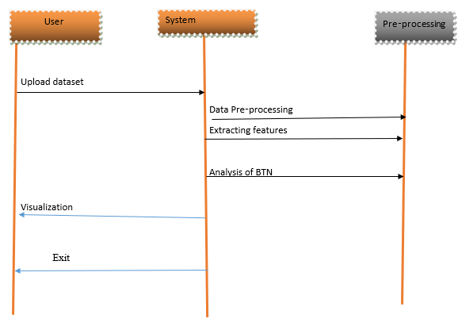
Class diagram
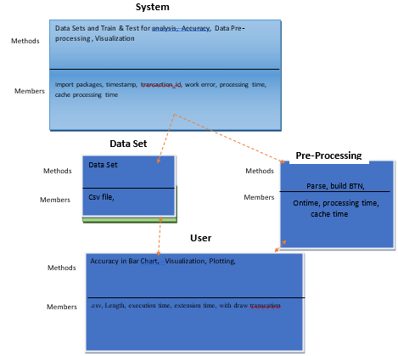

Coding

from tkinter import messagebox
from tkinter import *
from tkinter import simpledialog
import tkinter
from tkinter import filedialog
from tkinter.filedialog import askopenfilename
import pandas as pd
import numpy as np
import matplotlib.pyplot as plt
import datetime
import json
import timeit

main = Tk()
main.title("Analytical Approach for Future Blockchain Forensic Investigation of Bitcoin Transaction Network")
main.geometry("1300x1200")

global filename
cluster = {}
balance = 0
received = 0
suspected = []
petrinet = []
withdraw = 0
deposit = 0
cache = []
global propose, extension

def uploadDataset():
global dataset
text.delete('1.0', END)
filename = askopenfilename(initialdir = "Dataset")
dataset = pd.read_csv(filename)
text.insert(END,str(dataset))

def parseDataset():
global dataset
global petrinet
petrinet.clear()
text.delete('1.0', END)
cluster = {}
for i in range(len(dataset)):
transaction = dataset.get_value(i, 'transaction_id')
timestamps = dataset.get_value(i, 'timestamp')
inputs = json.loads(dataset.get_value(i, 'inputs')).get('inputs')[0]
outputs = json.loads(dataset.get_value(i, 'outputs')).get("outputs")
if inputs is not None: #petrinet always fire event when input is available and not none in the transaction and then add an address to perform BTN analysis
petrinet.append([inputs,outputs])
trans_time = pd.to_datetime(int(str(timestamps)), utc=True, unit='ms')
text.insert(END,"Parse transaction transition of petrinet: "+str(transaction)+" on time: "+str(trans_time)+"\n")
for i in range(len(petrinet)): #cluster the addresses
data = petrinet[i]
outputs = data[1]
for j in range(len(outputs)):
output = outputs[j]
addr = output.get("output_pubkey_base58")
if addr is not None:
if addr in cluster.keys():
cluster[addr] = cluster.get(addr) + 1
else:
cluster[addr] = 1
font = ('times', 15, 'bold')
title = Label(main, text='Analytical Approach for Future Blockchain Forensic Investigation of Bitcoin Transaction Network')
title.config(bg='bisque', fg='purple1')
title.config(font=font)
title.config(height=3, width=120)
title.place(x=0,y=5)

font1 = ('times', 13, 'bold')

uploadButton = Button(main, text="Upload Blockchain Transaction", command=uploadDataset)
uploadButton.place(x=50,y=100)
uploadButton.config(font=font1)
font1 = ('times', 13, 'bold')
text=Text(main,height=20,width=140)
scroll=Scrollbar(text)
text.configure(yscrollcommand=scroll.set)
text.place(x=10,y=250)
text.config(font=font1)

main.config(bg='cornflower blue')
main.mainloop()

